ELEC 105 Laboratory Exercise #4 Spring 2010

Voltage Dividers in Action

Why is this important?

The weather! During much of the year, we try to control our environment. During the summer, we might use fans to help cool a living area. During the winter, we might use a fan or blower attached to the furnace to force hot air throughout a home. In each situation, the need to move air depends on the temperature of the air in the home. Being energy conscious, we would want the fan to run only when necessary. During the summer, we would want a system that would run the fan when the temperature rises above a set value, and in the winter, we would want to run the fan when the temperature falls below a particular threshold in order to distribute the warm air in a room.

Goal: Design an electronic fan control circuit that will cause a fan to turn on when the temperature rises above a pre-set threshold and will vary the speed of the fan with temperature.

Lab Report

In a well-organized, professional-style document, outline the process you used to design the fan control circuit described below. Include any important intermediate steps you took and any measurements and/or observations you made to verify the circuit’s proper operation. You should provide enough details and background information so that a technically competent but uninvolved reader could understand the results you are presenting. (Imagine that a high-level manager, who has only a vague idea of your task, has asked for a report on your activities.) Remember to include other details that are helpful to readers, such as an introduction and conclusion, diagrams, units on values, annotations on graphs, well-defined variables, etc. You do not have to include the tasks outlined in Steps 1-4 below in your report, but you should show the calculations you used to determine the temperature coefficient of the thermistor. Each lab team should submit a single report with the names of all of the students who worked together. Your report will be due at the beginning of the lab session next week. Lab reports are weighted 100 points each.

Procedure

- In a voltage divider, the voltage across each resistor is a fraction of the source voltage. For the circuit shown in Figure 1, calculate V_{O} and the voltage across R₁ using the principle of voltage division.

12 V
+
−

R₁
1.0 kΩ
R₂
2.7 kΩ
+

V_{o}

−
Figure 1. Voltage divider circuit.

- Using the power supply as the 12-V source, build the voltage divider shown in Figure 1, and measure the voltages. Do the measured and calculated values agree?

- A thermistor is a type of resistor that has been designed to have a resistance that varies with temperature. Obtain a thermistor and measure its resistance at room temperature and at body temperature. (Hold the thermistor between your fingertips for the latter measurement.) Does the resistance decrease or increase as the temperature increases? Determine the temperature coefficient (i.e., the change in resistance per degree Celsius) for the thermistor. Assume that room temperature is 75°F (24°C) and that the temperature between your fingertips is 90°F (32°C). Is the temperature coefficient negative or positive?

- What would happen if you were to replace R₁ in the voltage divider with a thermistor? How would V_{O} vary with temperature? What would you expect V_{O} to be if the thermistor were at room temperature? If it were placed between your fingertips? Build the circuit and find out if your answers were correct. Demonstrate the circuit to your instructor.

- In the next few steps, you will be asked to design a circuit to run a fan when the temperature rises above about 82°F. The fan speed should increase as the temperature increases. Note that you cannot simply connect a fan across one of the resistors in a voltage divider because the fan will draw a significant amount of current (unlike a voltmeter, whose current draw is negligible). Hence, the voltage divider formula would not apply. Instead, you will use a transistor (actually, a pair of transistors called a Darlington pair) that behaves like a voltage-controlled voltage source to control the fan in response to the voltage divider output. A slight complication is that the “voltage source” isn’t linear; it produces 0 V when the input (controlling voltage) is less than about 1.2 V. Above that point, its output voltage (the voltage source voltage) increases by the same amount as the input voltage. This behavior is depicted in Figure 2 and is expressed mathematically as V_{o} = 0 for V_{in} < 1.2 V and V_{o} = V_{in} – 1.2 for V_{in} > 1.2 V. Your design will have to take the 1.2-V offset into account.

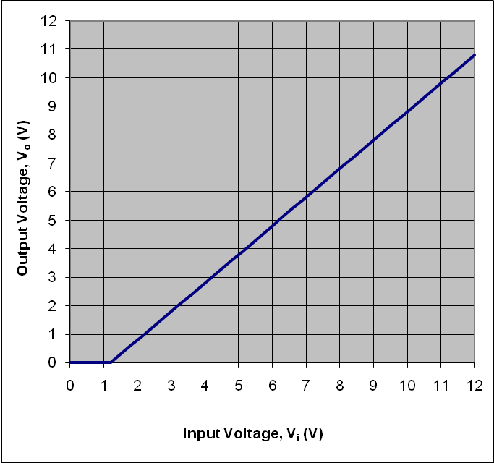

Figure 2. Transfer characteristic of Darlington pair.
- Another important point is that although the fans you will be using have a labeled operating voltage of 12 V, they in fact operate at much lower voltages as well. However, the fans will not turn on until the voltage across their terminals rises above a certain threshold value. You will need to determine the threshold voltage for your particular fan and take it into account in your design. The best way to do this is to connect the fan directly to the 25-V power supply and slowly increase the supply voltage from zero until the fan starts to operate. You should determine the threshold voltage to the nearest 0.1 V.

- Figure 3 shows an example of how the Darlington pair should be incorporated into the circuit. It is the device with the three terminals labeled E, B, and C (corresponding to emitter, base, and collector). A pin-out diagram (which identifies the terminals) for the device should be available from the instructor. The same 12-V source that runs the fan can be used for the voltage divider. In fact, using the same source ensures that the divider and fan circuits have the same voltage reference. An important characteristic of the Darlington pair is that the current that flows into the base terminal (labeled B) is very, very small, so small that it can be considered negligible.

12 V
+
−

to voltage
divider
“output”
(central
node)
fan
+
V_{o}
−
+

V_{in}

−
E
C
B

Figure 3. Fan control circuit. The voltages labeled V_{in} and V_{o} are the input and output voltages, respectively, of the Darlington pair and correspond to V_{i} and V_{o} in Figure 2.

- Design a voltage divider circuit using a thermistor that, when connected to the proper places in the circuit shown in Figure 3, will cause the fan to turn on when the temperature rises above approximately 82°F. Have the lab instructor approve your design, then build and test it. Hair dryers or other heat sources should be available to allow you to heat up the thermistor quickly. You can also try holding it between your fingertips again. Does the circuit function as you expected? You might try measuring various voltages in the circuit to confirm that they change appropriately as the temperature changes.

Acknowledgement

This lab hand-out is adapted from one originally prepared by Prof. Sam Craig.

