Digital Logic Exercise

Consider the following digital logic circuit diagram.

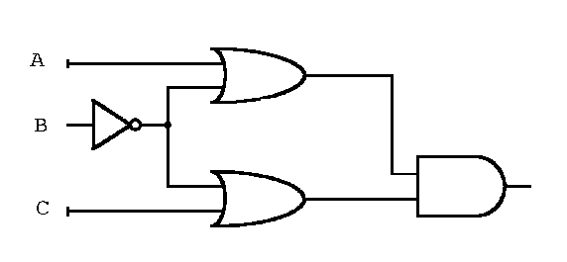

- Determine the Boolean expression that is represented by the logic circuit.
- Write the truth table for the circuit.
- Write a Boolean expression in standard sum-of-products form.
- Use a Karnaugh map (K-map) to obtain a simplified Boolean expression. Verify that your simplified expression has the same truth table.
- Draw a logic circuit diagram for your simplified expression using AND, OR, NOT gates.
- Draw a logic circuit diagram using only NAND gates.

