ELEC 105 Laboratory 12 April 28, 2004

Envelope Detection of Amplitude Modulated (AM) Waveforms

In this lab, we will use the envelope detector to recover the “message” signal from an AM waveform.

Lab Procedure:

- Set up the function generator to produce an AM waveform with carrier frequency 100 kHz and a sine wave message with frequency 1 kHz (we will show you how to do this). Display the AM waveform on the oscilloscope. The amplitude of the AM wave should be at least 2 volts.
- Using a diode and a capacitor with value C = 0.1 μF, choose an appropriate value for the resistor, R, in the envelope detector so that the output will follow the 1 kHz sine wave message signal.

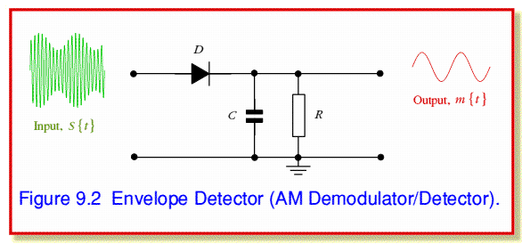

- Set up the envelope detector circuit and test your design. First show the output without the capacitor. What does the circuit do without the capactor? Then insert the capacitor, and make rough sketch of the output signal in your lab notebook.
- Try changing the carrier frequency and message frequency as follows:
Message 1 kHz, carrier 10 kHz and 1 MHz
Carrier 100 kHz, message 100 Hz and 10,000 Hz
For which cases does the envelope detector “work,” so that the output looks like the message? Please explain.

