ELEC 105 Laboratory 3 Feb. 4 and 11, 2004

Voltage Dividers in Action

Why is this important? The weather! During much of the year, we try to control our environment. During the summer, we may use fans to help cool a living area. Now, during the recent cold snap, we may use a fan or blower attached to the furnace to force hot air throughout a home. In each situation, the need to move air would be dependent on the temperature of the air in the home. Being energy conscious, we would want the fan to run only when necessary. Thus, in summer, we would want a system that would run the fan when the temperature was above a set temperature. In winter, we would want to run the fan when the temperature fell below a set temperature.

Problem of the Day: Can we design a system in which the speed of the fan is dependent on the temperature of the room?

Instructions

- The resistance of a thermistor varies with the temperature of the thermistor. Measure the resistance of a thermistor at three temperatures: room temperature, squeezing it between your fingers, and with a hair dryer blowing on it. Does the resistance decrease or increase as the temperature increases?
- In a voltage divider, the voltage across each resistor is a fraction of the source voltage. For the circuit shown in Figure 1, calculate v₁ and v₂ using the principle of voltage division.

- Build the voltage divider shown in Figure 1. Measure v₁ and v₂. Do the measured and calculated values of v₁ and v₂ agree? (Make sure you measure the resistance of R₁ and R₂, since the actual values may be slightly different than the color code on the resistor!)
- What would happen if we replaced R₁ in the voltage divider with a thermistor? How would v₁ vary with temperature? What would you expect v₁ to be if the temperature of the thermistor was at room temperature? What would you expect v₁ to be if the thermistor is warmed by the hair dryer?
- Design a circuit to produce a voltage that would increase as the temperature in the room increased.
- Design a circuit to produce a voltage that would increase as the temperature in the room decreased.
- Build the circuit that produces a voltage that increases as the temperature in the room increases. Measure the voltage with the thermistor at room temperature. Then warm the thermistor with the hair dryer. Does the voltage increase as you warm the thermistor?
- Determine the value of the fixed resistor in your voltage divider circuit that maximizes the change in voltage between room temperature and the hair dryer. (Note: This is item 3 on Homework 3.)
- Design a circuit to run a fan when the temperature rises above room temperature (about 70º F). The fan speed should increase as the temperature increases. Note that adding the fan (motor) will change the function of your design because the fan will draw current from the circuit. (Think about why this is true!) Since we want the voltage divider to work pretty much like theory predicts, we can't connect the motor directly to it. To keep the motor from drawing significant current from the voltage divider, we will use a transistor that behaves like a voltage-controlled voltage source. However, it will need an input of about 1.2V before the fan motor starts to turn. Have the lab instructor approve your design, then build and test it. Did it function? Does the motor run faster when you turn on the hair dryer?

Can we improve the design?

Let’s design a new controller that starts the motor at room temperature and has the motor cranking at full speed at the temperature provided by the hairdryer.

Below is a “bridge” circuit and some facts about the bridge circuit. Design a bridge circuit with your thermistor that will control the motor as desired. We will provide you with a potentiometer (pot) that you can use to calibrate the bridge (use the pot in place of R_{A} or R_{B}).

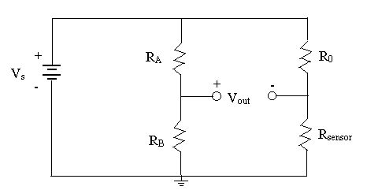

The bridge circuit is really just two voltage dividers. The output voltage V_{out} is the difference between the two sides of the bridge. If the circuit components are chosen properly, the voltage difference will be zero. Show that the conditions for a “balanced bridge” are

