ELEC 105 Laboratory 5 February 25, 2004

Introduction to Operational Amplifiers

Why is this important? Operational-amplifiers (op amps) are significant because they are used in a wide variety of applications, ranging from audio to instrumentation to signal processing. Circuits that include op-amps can perform mathematical operations on voltages or currents, like addition, subtraction, multiplication, differentiation, and integration. Hence the name operational amplifier.

The op-amp looks simple, but it's actually a fairly complex device. If you could see inside the black plastic package, you would find a tiny “chip” of silicon -- an integrated circuit with transistors, along with diodes and devices that act like resistors and capacitors. There are many different types of op amps. The type “741” that we are using was one of the first integrated circuit op-amps to appear on the market. Although other types have been developed with much better performance, the 741 remains popular because it is inexpensive and easy to use.

In this lab, we will use the op amp to perform some functions such as voltage amplification and addition.

Lab Procedure:

1. Inverting Amplifier
- Repeat the analysis that leads to the result that the output voltage V_{out} is related to the input voltage V_{in} according to V_{out} = -(R₂ / R₁) V_{in} in Figure 1.
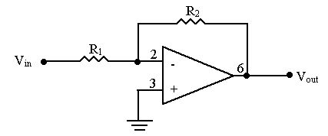

Figure 1- "Inverting amplifier" with 741 op amp
- Suppose you want to design an inverting amplifier with gain = -(R₂ / R₁) = -10. Ideally, any resistor values that satisfy R₂ = 10 R₁ will work. However, with real op amp circuits, the resistor values need to be chosen with some care. Which of the following combinations of resistors would be the best selection for designing an inverting amplifier with a gain of –10:
R₁ = 1 ohm and R₂ = 10 ohm, or R₁ = 1 k ohm and R₂ = 10 k ohm, or R₁ = 1 M ohm, R₂ = 10 M ohm? (Hint: The current into/out of the op amp should be less than 25 mA.)
- Build an inverting amplifier with v_{o} / v_{in} = -10. Figure 2 shows the pin diagram for the 741 op amp. Use voltages of +12 and –12 volts for +V and –V, respectively. Use the function generator to create a sine wave as your voltage supply for v_{in}. Set the amplitude of the input voltage by selecting “Ampl”, “Enter Number”, “0.5”, and “Vpp” on your function generator. Measure v_{o} and v_{in} with the oscilloscope. Connect v_{in} to channel one and v_{out} to channel two.
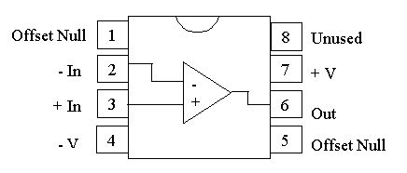

Figure 2- Pin Diagram for 741 op amp
Complete the following table: (For “Shape of Output Voltage”, pick the following term that best describes the waveform: sinusoidal, triangular, clipped sinusoidal, or clipped triangular.)

Frequency(kHz) | Vin(Vpp) | Vout(Vpp) | Shape of Output Voltage
0.1
1
10
20
30
40
50
60
100

At which frequency does the output look distorted compared with the input? Do you have any ideas why? Sketch the distorted output signal when the frequency gets too large.

- Set the frequency at 1000 Hz, but increase the amplitude of the input signal. What is the largest value that you can set the input amplitude before the output wave gets “clipped?” What are the maximum and minimum values of the clipped output signal? Make a sketch of the clipped output signal, showing the maximum and minimum voltage values. Why does the clipping occur?

Summing Amplifier

Design, build, and demonstrate a summing amplifier that meets the following specifications. We will provide potentiometers with resistance from 0 to 5000 ohms.

Input voltage sources: 1 volt DC and 2 volt peak-to-peak sinusoidal waveform with frequency 500 Hz.

Output: Weighted sum of the two sources, where the DC voltage is variable from -0.5 V to -2 V and the sinusoidal voltage is variable from 1 V peak-to-peak to 4 V peak-to-peak.

Provide a complete diagram of your circuit in your lab notebook. Sketch some of the output waveforms in your lab notebook.

