Laboratory 1: Frequency Response Measurements
January 16 and 23, 2003

Introduction: The objective of this lab is to review measuring the frequency response (magnitude and phase) of a low pass filter. We will try to relate your measured results to analysis using phasors and impedance as well as simulation with PSpice.

Background: We will consider the following low pass filter circuit.

Instructions:

- Analytically determine the frequency response of the circuit for both the magnitude gain and the phase difference between the input and output signals at sinusoidal steady state.
- “Build” the circuit in Figure 1 in Pspice. In the Setup menu, select “AC Sweep”. For the ac sweep, select a start frequency of 100 Hz, an end frequency of 100 kHz and an AC sweep type of “decade”. Save your schematic and then select “Simulate” from the Analysis menu. In Probe, plot v_{out}/v_{in}. This will plot the magnitude of v_{out}/v_{in}.
- Copy the magnitude data to Excel by highlighting (clicking) the name of the variable at the bottom of the plot and then copying the data using the “copy” button or “Copy” from the Edit menu. When the data are selected the name of the variable will be highlighted in red. Open Excel. Select “Paste Special” from the Edit menu. Select “Paste” and “as text” and then “ok”. Later in the lab, you will plot the data along with the experimental data to be measured during this lab.
- In Probe, delete all traces. Plot the phase angle between v_{in} and v_{out}. Select “Add” from the Trace menu. On the right hand of your menu will be options for different functions: ATAN (calculates the inverse tangent in radians), IMG (takes the imaginary part of the variable selected), and R (takes the real part of the variable selected). To plot the phase difference between v_{in} and v_{out}, select ATAN(IMG(v_{out})/R(v_{out}))*360/2/pi where v_{out} is the voltage across the capacitor in your circuit. (This assumes that you left the phase angle of v_{in} as zero degrees when you “built” the circuit.) Copy this phase angle data to Excel.
- Experimentally measure the the magnitude of v_{out}/v_{in} and the phase difference between v_{in} and v_{out} from 100 Hz to 100kHz. Set the function generator to sine and select an amplitude of 1 Vpp. Record your experimental data in Excel.
- In Excel, plot the Pspice data of magnitude of v_{out}/v_{in} as a function of frequency using a logarithmic axis for the x axis and a scatter plot. Add the experimental data of magnitude of v_{out}/v_{in} as a function of frequency to the plot as another series. Also add data based on evaluating your analytical expression from item 1 (you can compute this data for a few frequencies using your calculator, or you can use formulas in Excel).
- In Excel, plot the Pspice data of the phase angle between v_{in} and v_{out} as a function of frequency using a logarithmic axis for the x axis and a scatter plot. Add the experimental data of the phase angle between v_{in} and v_{out} as a function of frequency as another series, and the analytical data.
- How do the experimental, Pspice, and analytical data compare?
- Can you identify the cutoff frequency in your plot, and compare it to the analytical cutoff?

Please go as far as you can with the following activities during the lab session.

The two circuits below are proposed as alternatives to the low-pass filter above. It is claimed that they might have better properties than the single-capacitor filter. Your problem is to investigate these two circuits and to determine if there is, in fact, any advantage to using either one of them instead of the original single-capacitor circuit.
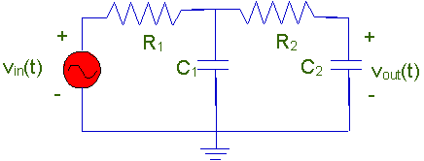
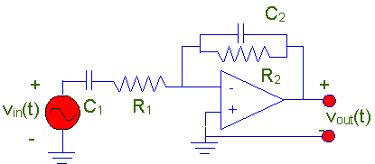

Begin with an analysis of these circuits. Then continue with wiring the circuits and PSpice simulation, as on page 1 for the single capacitor circuit.

